weights = [1.5, 0.5, 1.0]

1 run...

training 1 epoch...

150.13919496536255 seconds used......

1 training finished! average train loss: 0.605391968857354

evaluating...

Confusion matrix, without normalization

[[ 817 94 111]

[1463 3824 120]

[1845 196 8724]]

Normalized confusion matrix

[[0.79941292 0.09197652 0.10861057]

[0.27057518 0.70723137 0.02219345]

[0.17138876 0.01820715 0.81040409]]

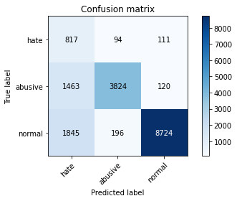

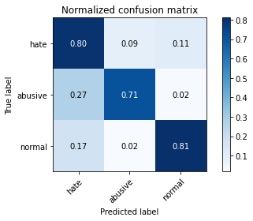

precision recall f1-score support

hate 0.20 0.80 0.32 1022

abusive 0.93 0.71 0.80 5407

normal 0.97 0.81 0.88 10765

accuracy 0.78 17194

macro avg 0.70 0.77 0.67 17194

weighted avg 0.91 0.78 0.83 17194

average eval_loss: 0.5522907842210559, accuracy: 0.7773060369896475

training 2 epoch...

150.18228149414062 seconds used......

2 training finished! average train loss: 0.43317013027032936

evaluating...

Confusion matrix, without normalization

[[ 735 124 163]

[1214 4013 180]

[1209 204 9352]]

Normalized confusion matrix

[[0.71917808 0.12133072 0.15949119]

[0.22452377 0.74218606 0.03329018]

[0.11230841 0.0189503 0.86874129]]

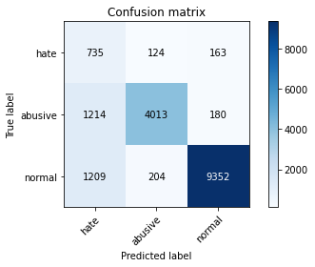

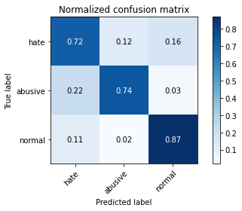

precision recall f1-score support

hate 0.23 0.72 0.35 1022

abusive 0.92 0.74 0.82 5407

normal 0.96 0.87 0.91 10765

accuracy 0.82 17194

macro avg 0.71 0.78 0.70 17194

weighted avg 0.91 0.82 0.85 17194

average eval_loss: 0.4522500238013129, accuracy: 0.8200535070373386

training 3 epoch...

150.24227237701416 seconds used......

3 training finished! average train loss: 0.3061160369530219

evaluating...

Confusion matrix, without normalization

[[ 759 98 165]

[1495 3749 163]

[1286 214 9265]]

Normalized confusion matrix

[[0.74266145 0.09589041 0.16144814]

[0.27649343 0.69336046 0.03014611]

[0.11946122 0.01987924 0.86065954]]

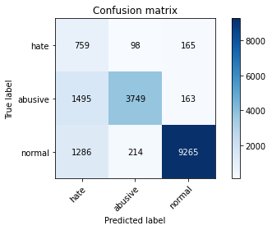

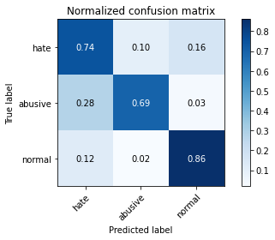

precision recall f1-score support

hate 0.21 0.74 0.33 1022

abusive 0.92 0.69 0.79 5407

normal 0.97 0.86 0.91 10765

accuracy 0.80 17194

macro avg 0.70 0.77 0.68 17194

weighted avg 0.91 0.80 0.84 17194

average eval_loss: 0.5197152212088885, accuracy: 0.8010352448528556

training 4 epoch...

150.23438334465027 seconds used......

4 training finished! average train loss: 0.2061152879703731

evaluating...

Confusion matrix, without normalization

[[ 772 109 141]

[1461 3804 142]

[1692 235 8838]]

Normalized confusion matrix

[[0.7553816 0.10665362 0.13796477]

[0.27020529 0.70353246 0.02626225]

[0.15717603 0.02183 0.82099396]]

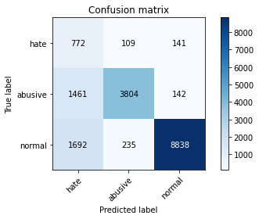

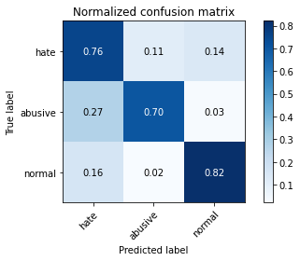

precision recall f1-score support

hate 0.20 0.76 0.31 1022

abusive 0.92 0.70 0.80 5407

normal 0.97 0.82 0.89 10765

accuracy 0.78 17194

macro avg 0.69 0.76 0.67 17194

weighted avg 0.91 0.78 0.83 17194

average eval_loss: 0.7531236455797456, accuracy: 0.7801558683261602

training 5 epoch...

150.22059273719788 seconds used......

5 training finished! average train loss: 0.14059215209091558

evaluating...

Confusion matrix, without normalization

[[ 806 99 117]

[1787 3487 133]

[2226 264 8275]]

Normalized confusion matrix

[[0.78864971 0.09686888 0.11448141]

[0.3304975 0.64490475 0.02459774]

[0.20678124 0.02452392 0.76869484]]

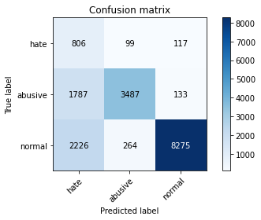

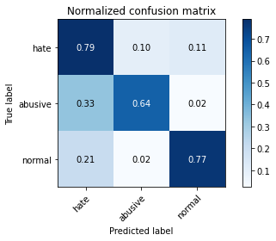

precision recall f1-score support

hate 0.17 0.79 0.28 1022

abusive 0.91 0.64 0.75 5407

normal 0.97 0.77 0.86 10765

accuracy 0.73 17194

macro avg 0.68 0.73 0.63 17194

weighted avg 0.90 0.73 0.79 17194

average eval_loss: 1.0114683627475833, accuracy: 0.73095265790392

2 run...

training 1 epoch...

150.2754852771759 seconds used......

1 training finished! average train loss: 0.6034892071921454

evaluating...

Confusion matrix, without normalization

[[ 789 101 132]

[1523 3742 142]

[1468 212 9085]]

Normalized confusion matrix

[[0.77201566 0.09882583 0.12915851]

[0.28167191 0.69206584 0.02626225]

[0.13636786 0.01969345 0.84393869]]

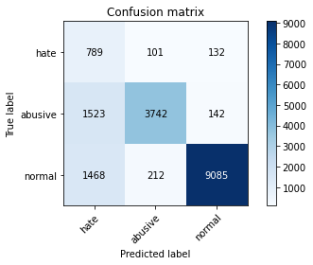

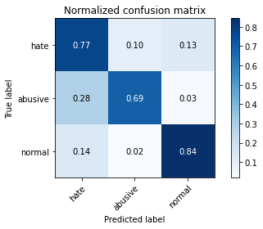

precision recall f1-score support

hate 0.21 0.77 0.33 1022

abusive 0.92 0.69 0.79 5407

normal 0.97 0.84 0.90 10765

accuracy 0.79 17194

macro avg 0.70 0.77 0.67 17194

weighted avg 0.91 0.79 0.83 17194

average eval_loss: 0.5235800166116205, accuracy: 0.791904152611376

training 2 epoch...

150.29626965522766 seconds used......

2 training finished! average train loss: 0.43566070724085276

evaluating...

Confusion matrix, without normalization

[[ 806 98 118]

[1540 3735 132]

[1652 211 8902]]

Normalized confusion matrix

[[0.78864971 0.09589041 0.11545988]

[0.28481598 0.69077122 0.0244128 ]

[0.15346029 0.01960056 0.82693915]]

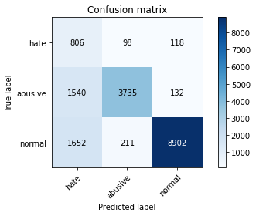

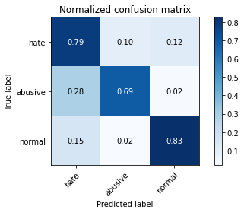

precision recall f1-score support

hate 0.20 0.79 0.32 1022

abusive 0.92 0.69 0.79 5407

normal 0.97 0.83 0.89 10765

accuracy 0.78 17194

macro avg 0.70 0.77 0.67 17194

weighted avg 0.91 0.78 0.83 17194

average eval_loss: 0.5331973918821923, accuracy: 0.7818425031987902

training 3 epoch...

150.3334677219391 seconds used......

3 training finished! average train loss: 0.3102831485729589

evaluating...

Confusion matrix, without normalization

[[ 760 142 120]

[1314 3941 152]

[1783 236 8746]]

Normalized confusion matrix

[[0.74363992 0.13894325 0.11741683]

[0.24301831 0.72886998 0.02811171]

[0.16562935 0.0219229 0.81244775]]

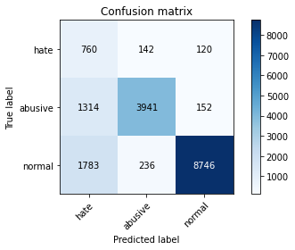

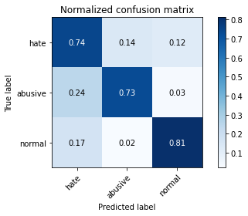

precision recall f1-score support

hate 0.20 0.74 0.31 1022

abusive 0.91 0.73 0.81 5407

normal 0.97 0.81 0.88 10765

accuracy 0.78 17194

macro avg 0.69 0.76 0.67 17194

weighted avg 0.91 0.78 0.83 17194

average eval_loss: 0.6784808183781976, accuracy: 0.7820751424915668

training 4 epoch...

150.2937307357788 seconds used......

4 training finished! average train loss: 0.19469725030724538

evaluating...

Confusion matrix, without normalization

[[ 750 138 134]

[1260 3984 163]

[1522 256 8987]]

Normalized confusion matrix

[[0.73385519 0.13502935 0.13111546]

[0.23303126 0.73682264 0.03014611]

[0.14138412 0.02378077 0.83483511]]

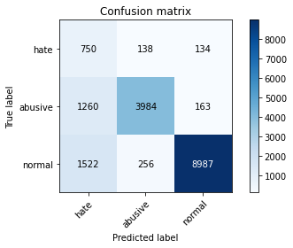

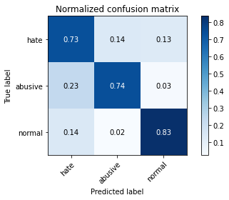

precision recall f1-score support

hate 0.21 0.73 0.33 1022

abusive 0.91 0.74 0.81 5407

normal 0.97 0.83 0.90 10765

accuracy 0.80 17194

macro avg 0.70 0.77 0.68 17194

weighted avg 0.90 0.80 0.84 17194

average eval_loss: 0.677618854731148, accuracy: 0.7980109340467605

training 5 epoch...

150.3393578529358 seconds used......

5 training finished! average train loss: 0.13423583041203815

evaluating...

150.29500436782837 seconds used......

1 training finished! average train loss: 0.5986197084592104

evaluating...

Confusion matrix, without normalization

[[ 774 104 144]

[1318 3953 136]

[1390 227 9148]]

Normalized confusion matrix

[[0.75733855 0.10176125 0.1409002 ]

[0.24375809 0.73108933 0.02515258]

[0.12912216 0.02108686 0.84979099]]

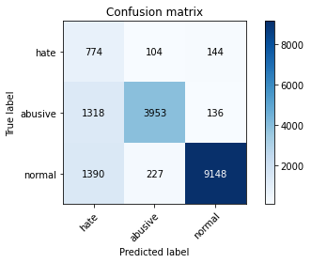

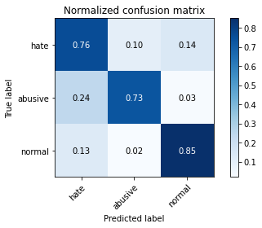

precision recall f1-score support

hate 0.22 0.76 0.34 1022

abusive 0.92 0.73 0.82 5407

normal 0.97 0.85 0.91 10765

accuracy 0.81 17194

macro avg 0.71 0.78 0.69 17194

weighted avg 0.91 0.81 0.84 17194

average eval_loss: 0.4792272710176401, accuracy: 0.8069675468186577

training 2 epoch...

150.33043479919434 seconds used......

2 training finished! average train loss: 0.43847375797027927

evaluating...

Confusion matrix, without normalization

[[ 809 91 122]

[1625 3616 166]

[1699 191 8875]]

Normalized confusion matrix

[[0.79158513 0.0890411 0.11937378]

[0.30053634 0.66876271 0.03070094]

[0.15782629 0.01774268 0.82443103]]

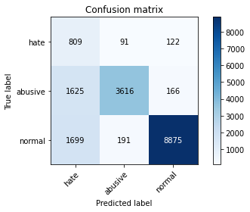

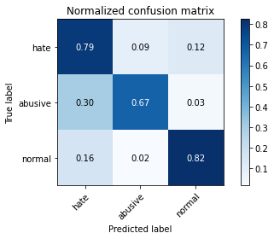

precision recall f1-score support

hate 0.20 0.79 0.31 1022

abusive 0.93 0.67 0.78 5407

normal 0.97 0.82 0.89 10765

accuracy 0.77 17194

macro avg 0.70 0.76 0.66 17194

weighted avg 0.91 0.77 0.82 17194

average eval_loss: 0.5301704117291889, accuracy: 0.7735256484820286

training 3 epoch...

150.3806300163269 seconds used......

3 training finished! average train loss: 0.3163494998526089

evaluating...

Confusion matrix, without normalization

[[ 822 83 117]

[1732 3541 134]

[1896 225 8644]]

Normalized confusion matrix

[[0.80430528 0.08121331 0.11448141]

[0.3203255 0.65489181 0.02478269]

[0.17612634 0.02090107 0.8029726 ]]

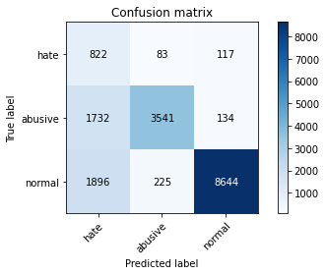

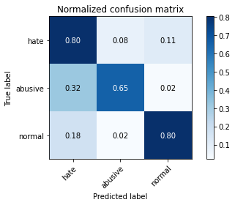

precision recall f1-score support

hate 0.18 0.80 0.30 1022

abusive 0.92 0.65 0.77 5407

normal 0.97 0.80 0.88 10765

accuracy 0.76 17194

macro avg 0.69 0.75 0.65 17194

weighted avg 0.91 0.76 0.81 17194

average eval_loss: 0.6469821602452633, accuracy: 0.7564848202861463

training 4 epoch...

150.32374024391174 seconds used......

4 training finished! average train loss: 0.20723722030410782

evaluating...

Confusion matrix, without normalization

[[ 762 103 157]

[1640 3603 164]

[1524 238 9003]]

Normalized confusion matrix

[[0.74559687 0.10078278 0.15362035]

[0.30331052 0.66635842 0.03033105]

[0.1415699 0.02210869 0.83632141]]

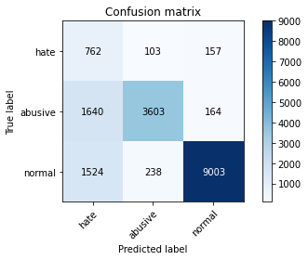

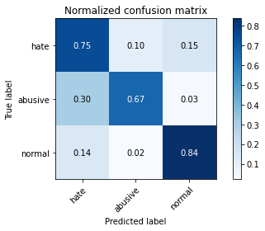

precision recall f1-score support

hate 0.19 0.75 0.31 1022

abusive 0.91 0.67 0.77 5407

normal 0.97 0.84 0.90 10765

accuracy 0.78 17194

macro avg 0.69 0.75 0.66 17194

weighted avg 0.90 0.78 0.82 17194

average eval_loss: 0.7014223569982447, accuracy: 0.77748051645923

training 5 epoch...

150.30427861213684 seconds used......

5 training finished! average train loss: 0.14711038838929033

evaluating...

Confusion matrix, without normalization

[[ 720 151 151]

[1203 4026 178]

[1359 330 9076]]

Normalized confusion matrix

[[0.70450098 0.14774951 0.14774951]

[0.22248937 0.74459035 0.03292029]

[0.12624245 0.0306549 0.84310265]]

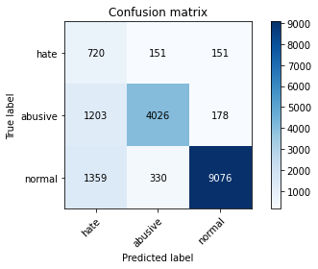

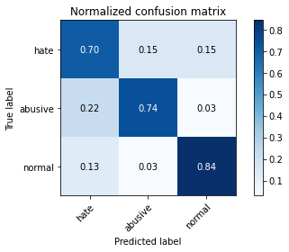

precision recall f1-score support

hate 0.22 0.70 0.33 1022

abusive 0.89 0.74 0.81 5407

normal 0.97 0.84 0.90 10765

accuracy 0.80 17194

macro avg 0.69 0.76 0.68 17194

weighted avg 0.90 0.80 0.84 17194

average eval_loss: 0.7217047254165071, accuracy: 0.8038850761893683

4 run...

training 1 epoch...

150.25976300239563 seconds used......

1 training finished! average train loss: 0.6075789621331084

evaluating...

Confusion matrix, without normalization

[[ 811 101 110]

[1420 3855 132]

[1813 222 8730]]

Normalized confusion matrix

[[0.79354207 0.09882583 0.10763209]

[0.26262253 0.71296468 0.0244128 ]

[0.16841616 0.02062239 0.81096145]]

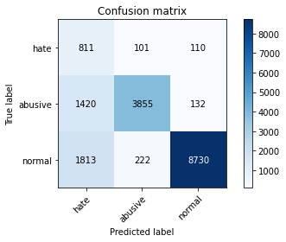

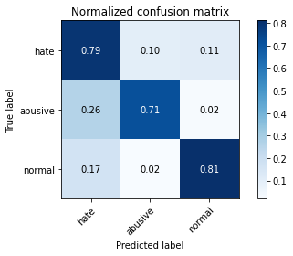

precision recall f1-score support

hate 0.20 0.79 0.32 1022

abusive 0.92 0.71 0.80 5407

normal 0.97 0.81 0.88 10765

accuracy 0.78 17194

macro avg 0.70 0.77 0.67 17194

weighted avg 0.91 0.78 0.83 17194

average eval_loss: 0.5513904034571592, accuracy: 0.7791089915086659

training 2 epoch...

150.3000705242157 seconds used......

2 training finished! average train loss: 0.43281100446497073

evaluating...

Confusion matrix, without normalization

[[ 732 130 160]

[1066 4152 189]

[1137 230 9398]]

Normalized confusion matrix

[[0.71624266 0.12720157 0.15655577]

[0.19715184 0.76789347 0.03495469]

[0.10562007 0.02136554 0.8730144 ]]

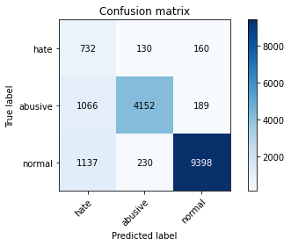

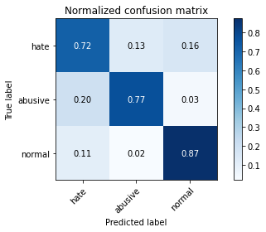

precision recall f1-score support

hate 0.25 0.72 0.37 1022

abusive 0.92 0.77 0.84 5407

normal 0.96 0.87 0.92 10765

accuracy 0.83 17194

macro avg 0.71 0.79 0.71 17194

weighted avg 0.91 0.83 0.86 17194

average eval_loss: 0.44657942685623503, accuracy: 0.8306385948586716

training 3 epoch...

150.18978595733643 seconds used......

3 training finished! average train loss: 0.30582531309491084

evaluating...

Confusion matrix, without normalization

[[ 783 95 144]

[1468 3749 190]

[1562 222 8981]]

Normalized confusion matrix

[[0.76614481 0.09295499 0.1409002 ]

[0.27149991 0.69336046 0.03513963]

[0.14509986 0.02062239 0.83427775]]

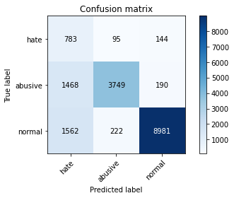

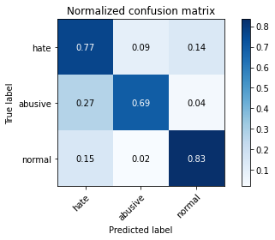

precision recall f1-score support

hate 0.21 0.77 0.32 1022

abusive 0.92 0.69 0.79 5407

normal 0.96 0.83 0.89 10765

accuracy 0.79 17194

macro avg 0.70 0.76 0.67 17194

weighted avg 0.91 0.79 0.83 17194

average eval_loss: 0.5781052097851453, accuracy: 0.7859136908223799

training 4 epoch...

150.2789158821106 seconds used......

4 training finished! average train loss: 0.2009767358176595

evaluating...

Confusion matrix, without normalization

[[ 697 162 163]

[1074 4146 187]

[1278 361 9126]]

Normalized confusion matrix

[[0.68199609 0.15851272 0.15949119]

[0.1986314 0.7667838 0.0345848 ]

[0.11871807 0.0335346 0.84774733]]

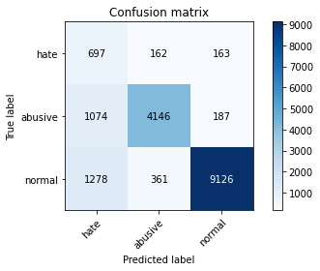

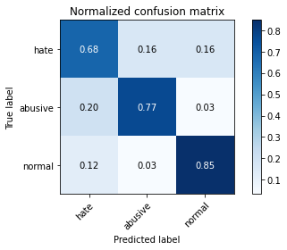

precision recall f1-score support

hate 0.23 0.68 0.34 1022

abusive 0.89 0.77 0.82 5407

normal 0.96 0.85 0.90 10765

accuracy 0.81 17194

macro avg 0.69 0.77 0.69 17194

weighted avg 0.90 0.81 0.84 17194

average eval_loss: 0.5960430779992495, accuracy: 0.8124345701989066

training 5 epoch...

150.25692629814148 seconds used......

5 training finished! average train loss: 0.13895252137392355

evaluating...

Confusion matrix, without normalization

[[ 754 108 160]

[1508 3668 231]

[1429 230 9106]]

Normalized confusion matrix

[[0.73776908 0.10567515 0.15655577]

[0.27889773 0.67837988 0.0427224 ]

[0.13274501 0.02136554 0.84588946]]

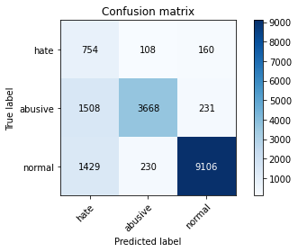

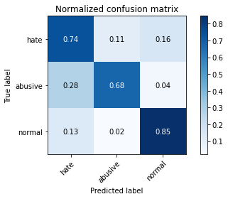

precision recall f1-score support

hate 0.20 0.74 0.32 1022

abusive 0.92 0.68 0.78 5407

normal 0.96 0.85 0.90 10765

accuracy 0.79 17194

macro avg 0.69 0.75 0.67 17194

weighted avg 0.90 0.79 0.83 17194

average eval_loss: 0.7958558644059786, accuracy: 0.7867860881702919

5 run...

training 1 epoch...

150.31240034103394 seconds used......

1 training finished! average train loss: 0.6226261078840454

evaluating...

Confusion matrix, without normalization

[[ 791 97 134]

[1383 3884 140]

[1372 224 9169]]

Normalized confusion matrix

[[0.7739726 0.09491194 0.13111546]

[0.25577955 0.71832809 0.02589236]

[0.12745007 0.02080817 0.85174176]]

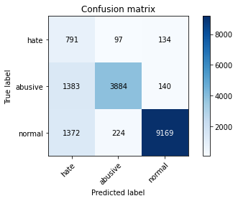

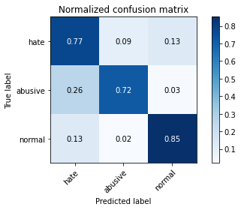

precision recall f1-score support

hate 0.22 0.77 0.35 1022

abusive 0.92 0.72 0.81 5407

normal 0.97 0.85 0.91 10765

accuracy 0.81 17194

macro avg 0.71 0.78 0.69 17194

weighted avg 0.91 0.81 0.84 17194

average eval_loss: 0.5206717902144721, accuracy: 0.8051645922996394

training 2 epoch...

150.29602479934692 seconds used......

2 training finished! average train loss: 0.44487638287162135

evaluating...

Confusion matrix, without normalization

[[ 800 80 142]

[1713 3529 165]

[1412 191 9162]]

Normalized confusion matrix

[[0.78277886 0.07827789 0.13894325]

[0.31681154 0.65267246 0.030516 ]

[0.13116582 0.01774268 0.8510915 ]]

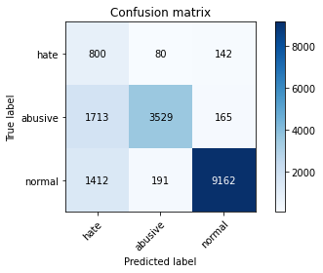

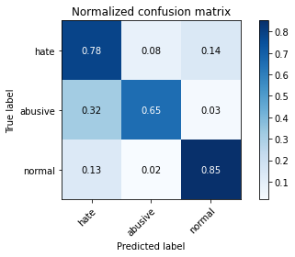

precision recall f1-score support

hate 0.20 0.78 0.32 1022

abusive 0.93 0.65 0.77 5407

normal 0.97 0.85 0.91 10765

accuracy 0.78 17194

macro avg 0.70 0.76 0.67 17194

weighted avg 0.91 0.78 0.83 17194

average eval_loss: 0.49041291421582534, accuracy: 0.7846341747121088

training 3 epoch...

150.26388001441956 seconds used......

3 training finished! average train loss: 0.3164848246638985

evaluating...

Confusion matrix, without normalization

[[ 757 132 133]

[1249 4015 143]

[1592 234 8939]]

Normalized confusion matrix

[[0.7407045 0.12915851 0.13013699]

[0.23099686 0.74255595 0.0264472 ]

[0.14788667 0.02173711 0.83037622]]

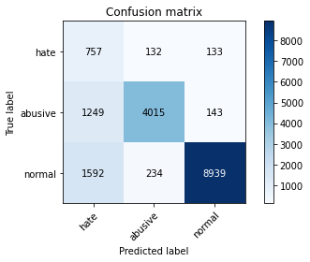

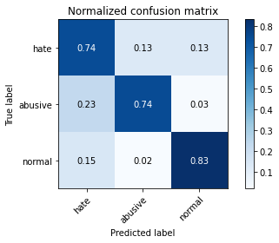

precision recall f1-score support

hate 0.21 0.74 0.33 1022

abusive 0.92 0.74 0.82 5407

normal 0.97 0.83 0.89 10765

accuracy 0.80 17194

macro avg 0.70 0.77 0.68 17194

weighted avg 0.91 0.80 0.84 17194

average eval_loss: 0.5770495938483712, accuracy: 0.7974293358148191

training 4 epoch...

150.5681848526001 seconds used......

4 training finished! average train loss: 0.20233596791986283

evaluating...

Confusion matrix, without normalization

[[ 753 121 148]

[1484 3757 166]

[1527 260 8978]]

Normalized confusion matrix

[[0.73679061 0.1183953 0.14481409]

[0.27445903 0.69484002 0.03070094]

[0.14184858 0.02415235 0.83399907]]

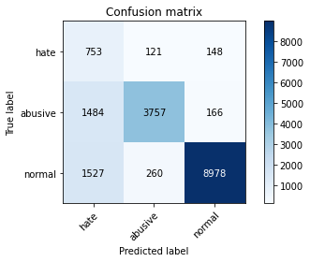

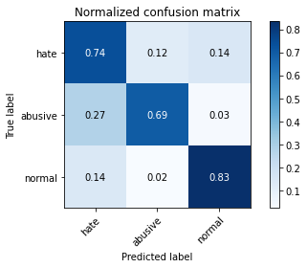

precision recall f1-score support

hate 0.20 0.74 0.31 1022

abusive 0.91 0.69 0.79 5407

normal 0.97 0.83 0.90 10765

accuracy 0.78 17194

macro avg 0.69 0.76 0.67 17194

weighted avg 0.90 0.78 0.83 17194

average eval_loss: 0.6699440810309593, accuracy: 0.7844596952425265

training 5 epoch...

150.3989269733429 seconds used......

5 training finished! average train loss: 0.13813492026743449

evaluating...

Confusion matrix, without normalization

[[ 771 127 124]

[1512 3740 155]

[1799 286 8680]]

Normalized confusion matrix

[[0.75440313 0.12426614 0.12133072]

[0.27963751 0.69169595 0.02866654]

[0.16711565 0.02656758 0.80631677]]

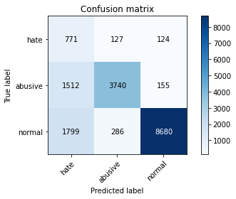

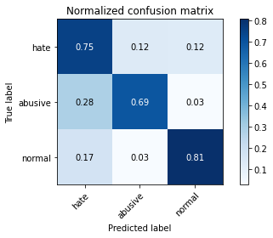

precision recall f1-score support

hate 0.19 0.75 0.30 1022

abusive 0.90 0.69 0.78 5407

normal 0.97 0.81 0.88 10765

accuracy 0.77 17194

macro avg 0.69 0.75 0.65 17194

weighted avg 0.90 0.77 0.82 17194

average eval_loss: 0.8563066854856388, accuracy: 0.7671862277538676